Session 1
Introduction to FLL Challenge – Unearthed

What is Unearthed?
This year’s theme focuses on archaeology – the science of uncovering the stories of people, cultures, and communities through artifacts, ruins, and underground sites. Archaeology helps us understand how humans interacted with the planet and with each other throughout history.
During this archaeology-inspired season, FIRST teams will use STEM skills, creativity, and teamwork to unearth new findings about ourselves and our communities—and to imagine how these discoveries can help build a better world.

Aspect | Archaeology 🏺 | Paleontology 🦖
Focus | Human history & culture | Prehistoric life (plants & animals)
What they study | Artifacts (tools, pottery, jewelry, buildings, tombs) | Fossils (bones, teeth, plants, shells)
Goal | Understand how humans lived, built, and interacted | Understand how life on Earth evolved and went extinct
Time Period | Past human history (thousands of years) | Prehistoric times, millions of years ago (before humans)
Methods | Excavations of cities, temples, graves, artifacts | Fossil digs, rock layers, carbon dating
Examples | Ancient Egyptian pyramids, Mayan temples, Stone Age tools | Dinosaur skeletons, woolly mammoth fossils, fossilized plants
Easy Memory Trick | Archaeology = People’s Past | Paleontology = Dino/Fossil Past

FLL Core Values
In FLL, everything we do is guided by the FIRST Core Values. These values make our work unique and meaningful
- Teamwork – We are stronger when we work together.
- Inclusion – We respect each other and embrace our differences.
- Impact – We apply what we learn to improve our world.
- Fun – We enjoy and celebrate what we do!
- Discovery – We explore new skills and ideas.
- Innovation – We use creativity and persistence to solve problems.
These values are expressed through the philosophies of Gracious Professionalism® and Coopertition®—always respecting others, sharing knowledge, and celebrating effort as well as results.
Core Values in Action
- Apply teamwork and discovery to explore the challenge.
- Use innovation to create new ideas for your robot and project.
- Show how your solutions have an impact and are inclusive.
- Always remember to have fun while learning and competing!
👉 At events, judges and referees will look for how your team applies these values—both in your robot design & innovation project presentation and during robot game matches.
Archaeology & Technology
Archaeology is no longer just digging with shovels. Today, archaeologists use a mix of traditional and modern technologies:
- Traditional methods: digging, excavation grids, ground-penetrating radar, sonar.
- Modern methods: muon tomography, satellite imaging, drones, and AI to “see” underground without digging.
What Are Muons?
- Muons are tiny, invisible particles that come from space (cosmic rays).
- They are like super-fast messengers that pass through air, mountains, and even the ground.
- Unlike light or X-rays, muons can travel deep into rock and soil.
How Muons Help Archaeologists
Scientists use muon detectors to capture and measure how muons travel through underground material.
- As muons pass through, some get absorbed or slowed down depending on what lies beneath.
- By measuring these patterns, scientists can build an “X-ray” map of the earth.
Real-World Examples
- Discovered hidden chambers in the Great Pyramid of Giza (2017).
- Monitored volcanoes safely by mapping lava chambers.
- Detected underground caves, tunnels, and ancient cities.
✅ Takeaway for Students:
This season is about digging deeper—not just into the ground, but into ideas, teamwork, and creativity. Archaeology + technology shows us how science helps uncover hidden worlds, and your FLL journey will do the same!
- STEM Topics
  - Particle accelerator

What is a Particle Accelerator? | A particle accelerator is like a giant super-fast racetrack for tiny particles.  - The “racers” are particles (like protons or electrons), which are way too small to see.  - The accelerator uses electric fields and magnets to push these particles faster and faster—almost to the speed of light.  - When the particles are going super fast, scientists make them crash into each other or into a target.
Why Crash Them? | When particles crash, they break apart into even smaller pieces, kind of like smashing LEGO bricks to see what they’re made of.  - This helps scientists understand the building blocks of the universe.  - It can also help make new discoveries—like finding new particles (e.g., the Higgs boson in 2012).  - Smaller accelerators are also used in medicine (like cancer treatments) and technology.
Medicine: Particle Accelerators in Cancer Treatment | - Radiation therapy: Small accelerators called linear accelerators (LINACs) create high-energy X-rays or electrons. Doctors aim these beams at tumors to kill cancer cells without needing surgery.  - Proton therapy: Special accelerators speed up protons instead of X-rays. Protons stop at a very precise spot inside the body, so doctors can destroy a tumor without damaging healthy tissue behind it.  - Fun fact: More than 30,000 accelerators worldwide are used in hospitals!
Technology & Industry | Making materials stronger: Accelerators can shoot particles into metals or semiconductors, changing their properties. This helps make stronger airplane parts or better computer chips.  Sterilizing medical equipment: Accelerators create beams that kill germs on syringes, bandages, or food packaging—without using heat or chemicals.  Imaging & scanning: Some accelerators are used to create intense X-rays for studying the structure of proteins, viruses, or new medicines at the atomic level.
Particle Accelerators & Computer Chips  What’s inside a chip? | A computer chip (or microchip) is like the “brain” of your phone, tablet, or laptop.  It’s made of tiny circuits built on silicon (a material from sand).  These circuits are unbelievably small—billions of transistors fit on a chip the size of your fingernail!
How accelerators help make chips | - To make chips work, scientists need to change the properties of silicon.  - Particle accelerators can fire ions (charged atoms) into the silicon.  - This process is called ion implantation.  - By carefully placing these ions, the silicon can be turned into different “zones” that let electricity flow in just the right way.  - Without this, the chip wouldn’t know how to switch on/off or process information.
Why not just use normal tools? | The features on chips are so tiny—measured in nanometers (nm), way smaller than a red blood cell—that only high-energy particle beams from accelerators can do this job accurately.  Accelerators allow pinpoint precision, so chips can become faster, smaller, and more powerful.
Everyday Impact | - Your smartphone, laptop, game console, or even a smartwatch has chips shaped by accelerators.  - Every swipe, tap, and video stream relies on accelerators that helped build the chip inside!

  - CERN large hadron collider
    - How does the Large Hadron Collider Work? | Colossal Machines | National Geographic UK
  - Muon Detector
    - Cosmic rays and the mummy's curse
  - An introduction to sub atomic particles
    - Quarks, leptons and bosons

1. Quarks – The Building Blocks of Matter
- Quarks are like the LEGO bricks of the universe.
- They combine to form protons and neutrons, which are inside every atom’s nucleus.
- There are 6 types (flavors) of quarks:
  - Up, Down, Charm, Strange, Top, Bottom.
- Protons = 2 up + 1 down quark.
- Neutrons = 2 down + 1 up quark.
2. Leptons – The Lightweight Family
- Leptons don’t need quarks; they exist on their own.
- The most famous lepton is the electron ⚡—the tiny particle that orbits the nucleus and carries electricity.
- There are 6 leptons in total:
  - Electron, Muon, Tau, and their 3 neutrinos (electron neutrino, muon neutrino, tau neutrino).
- Neutrinos are super hard to detect—they pass through your body all the time without you noticing!
3. Bosons – The Force Carriers
- If quarks and leptons are “players,” then bosons are the referees. They carry the fundamental forces of nature.
- Examples:
  - Photon – carries light and electromagnetism.
  - Gluon – “glues” quarks together inside protons and neutrons.
  - W and Z bosons – responsible for radioactive decay.
  - Graviton (theoretical) – would carry gravity if confirmed.
  - Higgs boson – discovered in 2012, it gives particles their mass.
Putting It Together
- Quarks + Leptons = Matter (they make up all stuff).
- Bosons = Forces (they make particles interact).
- Together, they form what scientists call the Standard Model of Particle Physics—like the rulebook for how the universe works at the smallest scale.
Takeaway for kids
- Quarks build things.
- Leptons move around on their own (like electrons).
- Bosons make sure everything interacts and sticks together.

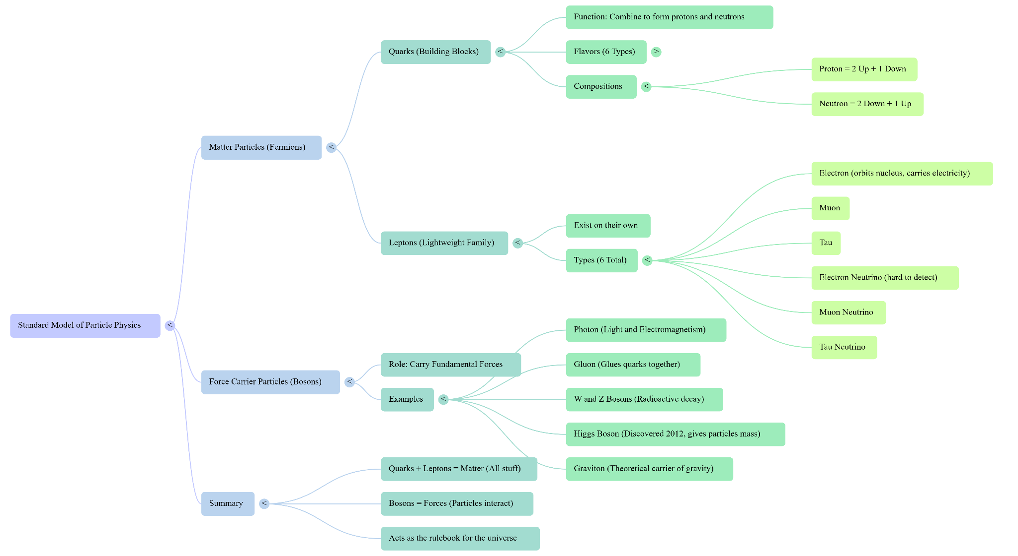

Brainstorm Ideas for Innovation project
  - Artifacts are very fragile, how to dig artifacts without breaking it
  - solutions to excavate very tight space ( build a sophisticated robotic arm )
  - maintain excavation grid accuracy ( user laser , positioning, gps , etc... )
  - accurately tag artifacts with excavation grids
  - capture 3d photographs of artifacts
  - sometimes its very difficult to identify artifacts ( use ai powered identifications methods )

Session 2

Improve Excavation Grids
Problem: Archaeologists must record exactly where every artifact was found. A wrong grid loses context.
Innovation Directions
- Laser grid system projected on excavation ground.
- AR goggles showing excavation squares.
- GPS tagging system that records coordinates instantly.
Prototype Tips:
- Use a LEGO robot that draws a grid on paper with a marker, representing excavation zones.
- Add a light sensor to detect position within the grid.
- Use an external laser pointer (safe classroom version) to demonstrate the grid concept.
Core Values Connection:
- Discovery: Understand why archaeology grids matter (context = meaning).
- Innovation: Use technology like survey drones/LiDAR for ancient sites.
- Impact: Prevent loss of critical information.
- Teamwork: Have students take turns “placing” artifacts and others record them.
- Fun: Turn it into a game — “place artifact in the correct square.”

Protecting Fragile Artifacts
Problem: Artifacts (like pottery or bones) are very delicate. Normal digging can break them.
Innovation Directions:
- Smart shovel/claw with pressure sensors that detect when an object is touched.
- Soft robotic fingers (inspired by octopus or medical robotics) that handle fragile objects.
- AI-assisted digging tool that warns when digging pressure is too high.
Prototype Tips:
- Use a LEGO SPIKE Prime arm with a force/color sensor to simulate detecting a fragile artifact (e.g., an egg or thin shell).
- Program the motor to stop moving when resistance/pressure is detected.
- Use soft material (sponge, balloon, silicone) on LEGO claws to show gentle handling.
Core Values Connection:
- Discovery: Research how real archaeologists and surgeons handle delicate work.
- Innovation: Apply robotics ideas from medicine into archaeology.
- Impact: Help preserve history without damaging it.
- Teamwork & Fun: Test different materials and laugh when the robot accidentally crushes the "artifact" at first — then improve together.

Excavating Tight Spaces
Problem: Many artifacts are found in caves, tunnels, or tight shafts. Humans can’t always reach.
Innovation Directions:
- Snake-like robots that crawl into tunnels.
- Drone + claw that can fly into cave-like structures.
- Mini digging rover that can fit into 10–20 cm spaces.
Prototype Tips:
- Build a long flexible LEGO robot arm that can bend around obstacles.
- Create a mock “cave” using a shoebox or cardboard tube and show the robot retrieving a small object.
- Use wheels or treads to show a tiny rover entering narrow passages.
Core Values Connection:
- Discovery: Learn about robots NASA designs for caves on Mars.
- Innovation: Adapt rescue robots for archaeology.
- Impact: Make discoveries in places humans cannot go.
- Inclusion & Teamwork: Assign roles — builder, coder, tester, designer of the cave environment.
- Fun: Pretend to be “archaeologists on Mars” while testing!

Artifact Tracking and Documentation
Problem: Each artifact needs a label, description, and discovery location — hard to manage manually.
Innovation Directions:
- RFID/NFC tagging system linked to GPS data.
- Mobile app for field entry with photos and notes.
- Blockchain-style record keeping so data isn’t lost or faked.
Prototype Tips:
- Create LEGO artifacts (bricks) with color-coded tags.
- Build a robot that scans color (or uses RFID if available) and logs data into a spreadsheet.
- Students can role-play: digger → scanner → recorder → database.
Core Values Connection:
- Discovery: Learn how museums catalog collections.
- Innovation: Combine mobile apps + sensors to save time.
- Impact: Make archaeological records more accurate.
- Inclusion: Every team member contributes — coding, data entry, presentation.
- Fun: Turn artifact scanning into a relay race.

Imaging
Problem: Some artifacts are too fragile to move. Researchers need high-quality digital images on site.
Innovation Directions:
- Portable 3D scanner (LiDAR, structured light, photogrammetry).
- Robot scanner on wheels that can move around the object.
- Drone scanner for big structures.
Prototype Tips:
- Program a LEGO robot to circle an object with a phone attached, taking photos from angles.
- Demonstrate with a clay pot as “artifact.”
- Use free software (like Meshroom or Tinkercad) to generate a 3D model from photos.
Core Values Connection:
- Discovery: Research how 3D scanning preserves heritage.
- Innovation: Adapt 3D tech to fragile dig sites.
- Impact: Keep records even if the artifact breaks later.
- Teamwork & Fun: Everyone takes turns scanning and stitching images.

Identification
Problem: Many artifacts look like plain stones — very hard to identify.
Innovation Directions:
- AI recognition app that compares photos to a database.
- Smart glasses that highlight likely artifacts.
- Texture scanner that checks surface patterns.
Prototype Tips:
- Train a simple image recognition model with Teachable Machine (Google) using pictures of “artifact vs rock.”
- Demo with a tablet — show how the AI predicts.
- For LEGO, make a robot that sorts “rocks” (different colored LEGO pieces) into categories.
Core Values Connection:
- Discovery: Learn about AI and how it can “see” patterns.
- Innovation: Apply modern computer vision to archaeology.
- Impact: Save archaeologists’ time and avoid missed discoveries.
- Inclusion: Artists/designers on the team can draw posters explaining how AI sees.
- Fun: Make a challenge: “Rock or Artifact?” game show.

Session 3

Improve Excavation Grids
Problem: Archaeologists must record exactly where every artifact was found. A wrong grid loses context.
Innovation Directions
- Laser grid system projected on excavation ground.
- AR goggles showing excavation squares.
- GPS tagging system that records coordinates instantly.
Using Drones
- Laser grid system projected on excavation ground.
  - This is probably not a good idea
Using Augmented Realty
- AR goggles showing excavation squares.
  - THis is probably a good idea to explore
Excavation Grids — Problems to Solve
- Uneven terrain: slopes/rocks distort squares; strings/markers stretch.
- Environment: wind/rain/dust remove markers; sunlight reduces visibility.
- Human error: tape/stake mis-measurements shift the entire grid.
- Poor visibility during digs: strings get buried/cut; reference points lost.
- Scaling: large sites take long to grid; small errors multiply.
- Drift over time: soil/weather/foot traffic move markers; re-alignment needed.
- Record-keeping: manual notes lead to errors; later digitizing is hard.

Directions (Pros & Cons)
Drones
- Pros: fast coverage; handles uneven terrain; easy re-checks; great for documentation.
- Cons: weather & battery limits; skilled piloting; weak in caves/indoors.
Laser Grid Projection
- Pros: instant, clear lines; no physical strings; quick setup; precise if calibrated.
- Cons: hard to see in bright sun; needs power; occlusion by people/objects; dust fragility.
AR Goggles
- Pros: personal, precise overlay; works when markers vanish; supports 3D (walls/trenches); links to GPS/data.
- Cons: expensive/heavy; power/calibration; software/GPS reliability; training needed.
Summary: Use drones for mapping big areas, lasers for active trench layout, AR for per-person precision + digital recording. A combo is the strongest.
Why AR if We Have Lasers?
- Lasers = shared “ruler on the ground”; great on flat surfaces; can be blocked/washed out; 2D only.
- AR = personal “digital ruler + notebook”; works in 3D, persists even if lines/markers disappear, ties to artifact metadata.
Summarize as a workflow link below
Lucidchart

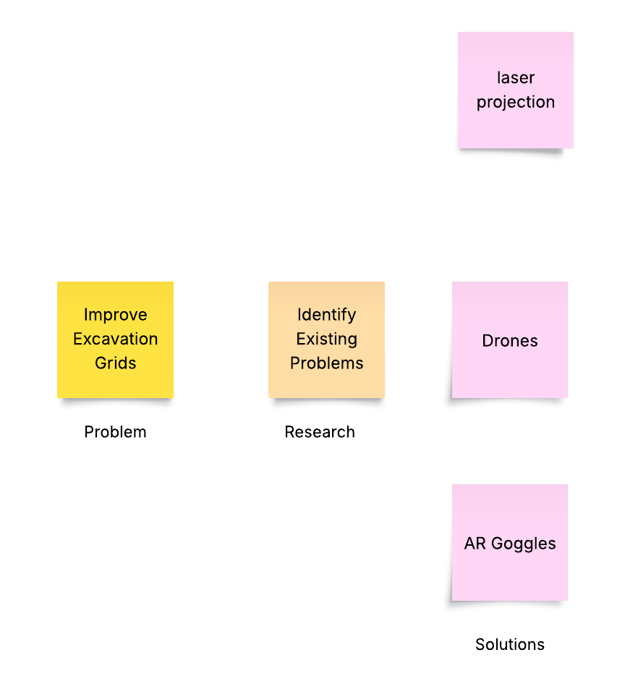

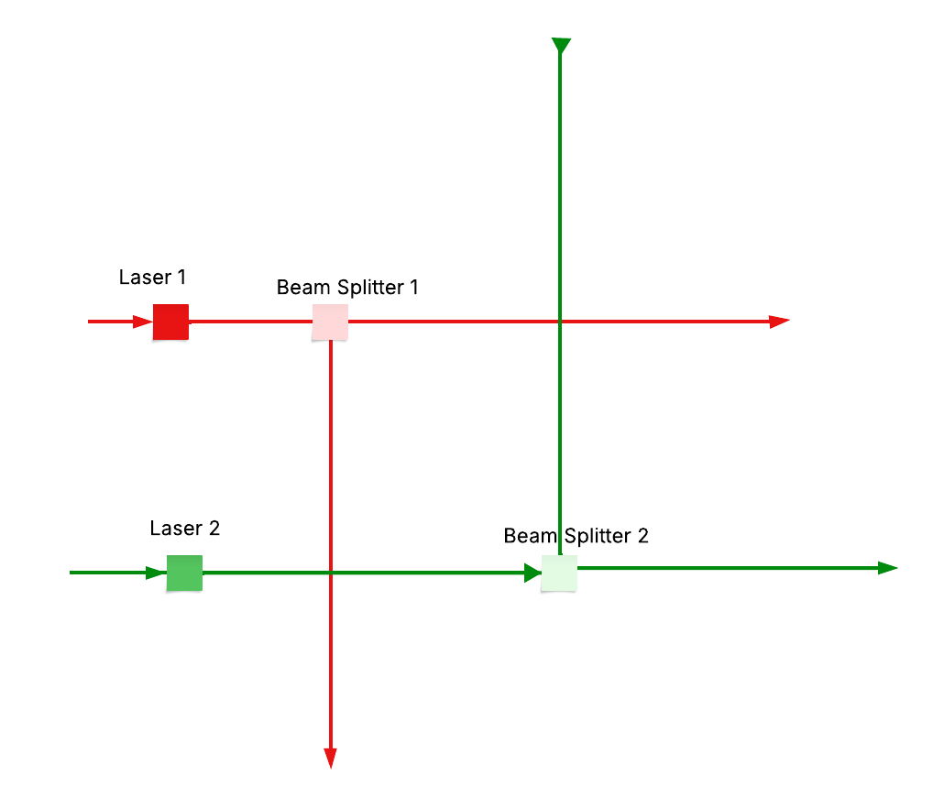

Prototyping: Laser Grid (FLL-ready)
Core parts: 2× low-power (≤5 mW) laser modules (green preferred), LEGO/tripod mounts, batteries/USB power, flat sand/cardboard “site.”
Enhancements: beam splitter or diffraction grating/line lens; small motor with mirror for sweep; light dust/fog for visibility.
Safety: eye safety, beam stops, classroom power levels.
Core Values: Discovery (survey/laser levels), Innovation (adapt to archaeology), Impact (accuracy), Teamwork/Inclusion (roles), Fun (demo with “mini dig”).
Making a Visible Grid (multiple lines)
- Option A (easiest): 2× cross-line laser modules side-by-side → parallel lines both axes → instant mini-grid.
- Option B: 2× line lasers + 1D diffraction gratings (one set rotated 90°) → controllable spacing, clean grid.
- Option C (beam splitters): cascade splitters to get 2→4 beams, add cylindrical/Powell lenses to turn dots into lines; repeat at 90°. Works but higher alignment effort.
Minimum lines: 2 vertical + 2 horizontal (4 total) to show a square; 3–4 per axis looks more “grid-like.”

Session 4

Research how to build a laser grid system

Lucidchart

Session 5
Detailed Study Notes
Topic: Laser Projection and Pico Projector Research
Team Project: Digital Excavation Grid for Archaeology (FLL Innovation Project 2026 – Unearthed)
OARA is pronounced “ohra”
The classes is organized and conducted by OARA Youth Innovation Lab, Vernon, BC
1. Background: Laser Grid Projection – Challenges in Scaling
During our early design experiments, we tried to model a laser-based excavation grid system using beam splitters and line lasers in 3D (Tinkercad).

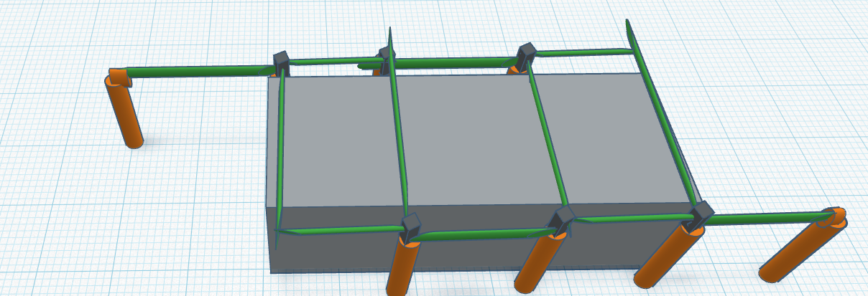
The idea was to project straight laser lines to form excavation squares, replacing manual string grids used in real archaeology.
Findings
- Each beam splitter can only divide one laser beam into two beams.
- To form a full grid (with multiple parallel lines in both X and Y directions), we would need many beam splitters and laser mounts.
- The system quickly became inefficient, complex to align, and difficult to scale.
Conclusion
While small-scale grids can be achieved with two lasers and a few splitters, scaling to full excavation sites would be mechanically cumbersome.
Therefore, we began exploring optical and digital alternatives, such as Diffractive Optical Elements (DOE) and pico projectors.

2. Further Research Topics
(A) Diffractive Optical Elements (DOE)
- A DOE can split or shape a beam into multiple patterns (lines, dots, grids).
- It’s a passive optical element — etched or molded glass/plastic that diffracts light into many controlled directions.
- Advantage: A single DOE can replace many beam splitters.
- Limitation: Hard to fabricate and requires specific wavelength matching.

Because DOE-based setups still involve laser safety concerns, we looked for a safer, more scalable projection method — leading us to the pico projector.

3. Pico Projector: Overview
Definition
A pico projector is a miniaturized, portable projector capable of displaying images, grids, or videos on walls, sand surfaces, or any flat area.
“Pico” refers to its tiny size—often small enough to fit in your pocket or be embedded into another device (e.g., a smartphone).
Core Concept
Pico projectors shrink the functionality of a traditional projector into a compact device by using low-power light sources and miniaturized optics.
Core Components
Component | Description
Light Source | Typically uses LEDs or laser diodes — efficient, compact, and long-lasting.
Display Chip | Generates the image using one of three main technologies:
– DLP (Digital Light Processing) | Tiny mirrors reflect light to form pixels.
– LCoS (Liquid Crystal on Silicon) | Combines LCD and silicon mirrors.
– LBS (Laser Beam Steering) | Uses moving mirrors to scan a laser beam pixel by pixel.
Optics | Lenses and mirrors focus and direct the image onto the surface.
Electronics + Battery | Power management, image processing, and connectivity (HDMI, USB, Wi-Fi).

4. Advantages and Limitations
Advantages
- Portability: Lightweight and fits in a pocket or small tripod mount.
- Ease of setup: No optical alignment required; ready-to-use.
- Connectivity: Supports HDMI, USB, or wireless (Wi-Fi / Bluetooth) input from smartphones or laptops.
- Multi-purpose: Can display grids, presentations, or educational videos.
Limitations
- Brightness: Works best in dim or shaded environments.
- Resolution: Lower than full-sized projectors (usually 720p).
- Image Size: Limited projection range; large images lose sharpness.
- Battery life: Typically 1–2 hours on internal battery.

5. Applications Beyond Archaeology
Field | Example Use
Education | Interactive classroom projections, portable STEM displays.
Business | Quick presentations, product demos, mobile sales kits.
Healthcare | Bedside imaging or visual aids for patient education.
Retail | Dynamic in-store displays or digital signage.
Gaming | Portable, immersive mini gaming setups.

6. DOE Integration in Pico Projectors
When Pico Projectors Use a DOE
- Laser-based LBS projectors often integrate a DOE for beam shaping and speckle reduction.
- The DOE diffuses or structures the light to improve uniformity and reduce flicker.
When They Don’t
- DLP and LCoS LED projectors do not need DOEs because they create images via micromirrors or liquid crystals, not direct laser scanning.
How to Identify
- If the specs mention “Laser Beam Steering” or RGB laser diodes, it likely includes a DOE.
- If the specs list LED light source with DLP or LCoS, it does not use one.

7. Battery-Powered Pico Projectors — Technology Breakdown
(A) DLP (Digital Light Processing)
- Uses thousands of tiny mirrors on a microchip to reflect light.
- A color wheel splits the beam into RGB light.
- Brightness depends on mirror tilt frequency.
- Pros: Compact, high contrast.
- Cons: Slight color breakup (“rainbow effect”).
(B) LCoS (Liquid Crystal on Silicon)
- Uses liquid crystals to modulate reflected light.
- Can achieve smoother color blending with subpixels or sequential color.
- Pros: Sharp images, good color.
- Cons: Slightly dimmer, slower refresh.
(C) LBS (Laser Beam Steering)
- Uses red, green, and blue lasers combined into one beam.
- Scanning mirror steers beam pixel-by-pixel at ~60 Hz.
- Pros: Always in focus, even on curved surfaces.
- Cons: More expensive; potential laser safety concerns; “speckle” patterns.

8. Why Pico Projectors Are Ideal for Our Project
🔍 Problem
Creating visible excavation grids safely and efficiently.
💡 Solution
A pico projector can project a digital grid pattern on the excavation site—
just like a laser grid, but safer, scalable, and easily modifiable.
Benefits
- Eliminates complex optics (no beam splitters or alignment).
- Works instantly with one image file.
- Grid pattern can be resized, recolored, or animated digitally.
- Safe for classrooms (no laser beams).
- Portable and battery-powered for outdoor archaeology demos.

9. Setting Up a Pico Projector for Excavation Grid Projection
Step 1: Create the Grid Image
- Design a grid using:
  - Image Editors: Photoshop, GIMP, or Paint.
  - Presentation Tools: PowerPoint or Google Slides.
  - Online Generators: patternprojector.com or similar.
- Use clear, contrasting lines (black or dark green) on a light background.
- Include optional coordinate labels (A1, A2, etc.).
Step 2: Get the Right Equipment
Equipment | Notes
Pico Projector | Choose LED-based, ≥100 lumens for indoor; ≥200 lumens for outdoor use.
Tripod Mount | Keeps projection stable and centered.
Power Source | Built-in battery or external USB power bank.
Display Source | Smartphone, tablet, or laptop (HDMI or Wi-Fi connection).
Step 3: Calibrate and Project
- Mount projector above center of site on a tripod.
- Adjust angle to minimize distortion.
- Use keystone correction to fix trapezoidal shape.
- Verify square accuracy by comparing projected grid with a physical ruler or object.
Step 4: Environmental Adjustments
- Use in dim light or shaded area for best contrast.
- Uneven surfaces will bend grid lines — great opportunity to discuss real-world mapping challenges in archaeology.

10. Example Classroom or FLL Application
Step | Description
Prepare Site | Sandbox or soil tray with hidden “artifacts.”
Mount Projector | On tripod, above or angled toward the center.
Project Grid | Display digital grid image; adjust for uniformity.
Excavation Activity | Students record artifact locations by grid reference (A2, B3, etc.).
Discussion | Reflect on accuracy, mapping, and how modern archaeologists use scanning and structured light techniques.

11. Summary: Key Takeaways
Concept | Description
Laser Grid Prototyping | Great for small demos but inefficient for large-scale grids.
DOE (Diffractive Optical Element) | Can shape beams into patterns but adds complexity.
Pico Projector | Compact, safe, flexible solution for scalable digital grids.
Learning Value | Demonstrates modern mapping, structured light, and projection in archaeology.
FLL Alignment | Discovery, Innovation, Impact, Teamwork, and Fun all demonstrated.

